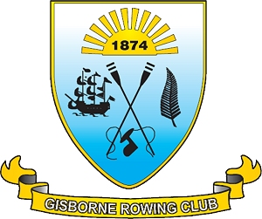

www.gisbornerowingclub.co.nz
email info@gisbornerowingclub.co.nz
P.O. Box 3070
Gisborne

JOHN HOWARD ROTORUA REGATTA NEWSLETTER 2013

Greetings to you all, it is that time again, regattas!, and the John Howard series Rotorua Lake regatta is upon us this coming weekend. To those who are going and you know who you are by now, we are leaving at 7.15am on Saturday the 13th July from Harry Barker Reserve. So please have your child there in plenty of time before the bus needs to leave.

We are staying at
All Seasons Holiday Park
50-58 Lee Road
Rotorua
Phone 64 73456240
Free phone 0800 422 674
Fax . 64 7 3456241
Email: info@allseasonsrotorua.co.nz

Jo’s phone number if you need to ring. 0273831552
Or Mandi on 0274546658

To keep costs down we are asking that every rower contribute to the food costs by donating a homemade pie, or grocery itemt or a pudding. I have rang you already on this and thank you so much for co-operating. If everyone could donate some baking as well it would be greatly appreciated.

We are loading boats on Wednesday at 5.oopm but will be advised by coaches if there are any changes to this plan. Each rower is expected to help with this, so please be there if you are going to the Rotorua Regatta.

Remember to bring your club singlets for racing, and all rowers are expected to be wearing club colours when down at the regatta, these being black and white.

Rowers need to take a day pack and a bag for your extra gear. In the day pack it would be beneficial for your rower if they bought the following:
Remembering this is a lake and the weather can turn cold.

White merino long sleeved thermals (2 preferably), can be worn under white singlets when racing.
Socks 2-4 for warmth and wearing in boat.
Track pants, warm. Black if possible, club colours.
Sweatshirts at least 1 black please.
Jacket, black
Warm footwear / ugg boots
Warm hats
Towel
Sunblock
Insect repel
Lip balm
Water bottle.
Sun hat. Club caps available for sale.

In the day bag please have some snacks:
Suitable suggestions:

Muesli bars, not too high in fat, below 10 in fat a good choice.
Dried fruit, scroggin mix
Fresh fruit, bananas are excellent for replacing energy.
Water bottle, filled
A bottle of Powerade, good to replace needed energy and nutrients after a race.

