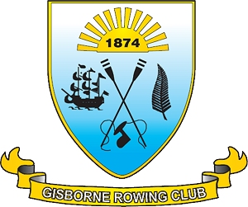
www.gisbornerowingclub.co.nz
email info@gisbornerowingclub.co.nz
P.O. Box 3070
Gisborne

APRIL NEWSLETTER 2013

CONGRATULATIONS
To all those who went to Maadi cup and competed. “This was one of the most successful Maadi cup regatta’s that Gisborne have been to,” is what our lovely coaches were heard to say. We had Nicole McBreen winning bronze in her single and the Gisborne Girls High School quad coming 6th in their A final. The Gisborne Boys High boys did very well also making a B final. Well done to you all who went and represented the Gisborne Rowing Club well.

END OF SEASON PARTY.
Everyone is invited to the end of year party held this Saturday the 6th April. Its at 274 Matokitoki valley rd and starts at 4pm and having dinner around 6.30. Please bring a plate or dish of something vegetable or meat to share and your own plates and cutlery. Bring what you may like to drink and your own glasses please as there may not be enough to go around. It may be helpful to bring a folding chair or something to sit on, so basically think picnic style.
We are looking forward to seeing you all there.

Our fabulous website www.gisbornerowingclub.co.nz is frequently updated and you can also find us on Facebook.

The Gisborne Rowing Club Committee

