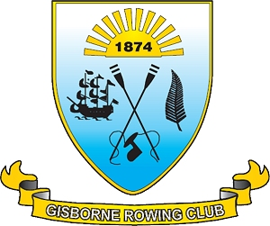

www.gisbornerowingclub.co.nz
email info@gisbornerowingclub.co.nz
P.O. Box 3070
Gisborne

11 April 2013

Hi all,
the end of the novi program is this Saturday, for all existing rowers we are having a working bee from 12.00 onwards. There will be a bbq from 3.00/3.30 onwards so will see you all there. There is no rowing this Sunday as no one will be around to take it.

Jo Ferkins
Secretary
Gisborne Rowing Club

